D-Day Landings
First Wave 1
MILITARY
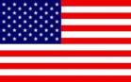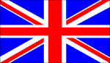
1ST US 2ND BRIT 1ST CAN
AIR POWER
N/A
RESOURCES
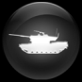
Pz Lehr Lose 1
12 SS Pz
ORDERS: 1 Action
+1 DRM Hitler
The operation was the largest amphibious invasion in world history, with over 160,000 troops landing on 6 June 1944. 195,700Allied naval and merchant navy personnel in over 5,000 ships were involved. The landings took place along a 50-mile (80 km) stretch of the Normandy coast divided into five sectors: Utah, Omaha, Gold, Juno and Sword.

